|  |  |  |  |
| --- | --- | --- | --- |
| **NAME:** |  | **INDEX NO:** |  |
| **SCHOOL:** |  | **SIGNATURE:** |  |

**273/1**

***🕮***

***🖎***

**Community**

UNNASE MOCK EXAMINATIONS

**GEOGRAPHY**

**Paper 1**

**August**

**2½Hrs**

***Uganda Certificate of Education***

**GEOGRAPHY**

**PAPER 1**

**2 Hours 30 Minutes**

**Instructions to Candidates**

* *This paper consists of parts* ***I*** *and* ***II***
* *Part* ***I*** *and section* ***A*** *of part* ***II*** *are compulsory*
* *Answer only* ***one*** *question from section* ***B*** *of part* ***II***
* *Answers to* ***all*** *questions* ***must*** *be written in the answer sheets provided*
* *Any additional question(s) answered will* ***not*** *be marked*

**PART I**

**OBJECTIVE – TYPE QUESTIONS (30 MARKS)**

*There are* ***30*** *compulsory questions.*

*Each question carries* ***one*** *mark.*

1. The Hills in North Eastern Uganda were mainly formed by the process of
2. Up warping B. Faulting

C. Volcanicity D. Denudation

1. Which one of the following minerals is mined in the southern highlands of Tanzania?
2. Gold B. Coal

C. Copper D. Diamonds

1. The major economic activity which is carried out along the saddle between Mt. Meru and Mt. Kilimanjaro is?
2. Forestry B. Ranching

C. Crop cultivation D. Wildlife conservation

1. The major problem facing cocoa growers in the southern highlands of Tanzania is
2. Poorly developed transport
3. Remote location from markets
4. High humidity which limits drying
5. Competition from other beverages
6. Which one of the following fault scarps is found in Tanzania?
7. Nyando B. Elgeyo

C. Chunya D. Kavirondo

1. Which one of the following crops is grown on plantations along the coastal plains of East Africa?
2. Sisal B. Ginger

C. Pyrethrum D. Wattle

1. The wide creeks along the East Africa coast are mainly important for
2. Harbours B. Settlement

C. Copra D. Conservation

1. Which one of the following towns in East Africa experiences hot and dry conditions in the months of May to October?
2. Nakuru B. Kitgum

C. Bukoba D. Dodoma

1. The relationship between soil water content and drainage along a slope is known as a
2. Soil pedon B. Soil catena

C. Soil Profile D. Soil Structure

1. Soil erosion in the dry plains of east Africa is mainly controlled by
2. Practicing contour ploughing
3. Carrying out mixed farming
4. The planting of cover crops
5. Practicing agro forestry
6. The absence of coral reef along river mouths at the East African coast is mainly because of
7. Muddy waters B. Cool waters

C. Salty waters D. Deep waters

1. The population density in the Serengeti pains of Tanzania is mainly influenced by
2. The remote location
3. Wildlife conservation
4. Infertility of the soils
5. The rain shadow effect.
6. Mining of iron are in south western Uganda is poorly developed because of the
7. Mining technology applied
8. Quantity of mineral deposits
9. Quality of rock mineral ore
10. Depth of mineral bearing rock
11. The eroded material deposited along the snout of a glacier is known as
12. Ground moraine B. Terminal moraine

C. Lateral moraine D. Medial moraine

1. The development of floriculture farming in East Africa is mainly limited by
2. The level of technology
3. The capital investment
4. The availability of market
5. The land tenure system
6. Which one of following pairs of game reserves are found in Tanzania?
7. Kyambura and Bokora B. Samburu and Boni

C. Bugungu and Ajai D. Kizigo and Muhesi

1. The major factor which speed s up chemical weathering in East Africa is the
2. Climate conditions B. Parent rock

C. Biological organisms D. Steep gradient

1. The small scale industries in East are well developed in East Africa are well developed mainly because they
2. Consume less energy
3. Face limited competition
4. Use cheap raw materials
5. Employ semi skilled labour
6. The use of mechanized agriculture by small scale farmers in eastern Uganda is mainly influenced by the
7. Small size of the plots
8. Availability of loan capital
9. Ready market for their crops
10. Employ semi skilled labour
11. The dominant weathering process which takes place in the wetlands of central Uganda is
12. Hydrolysis B. Aridity shrinkage

C. Pressure release D. Granular disintegration

1. Which one of the following types of precipitation is least experienced in East Africa?
2. Fog B. Snow

C. Mist D. Sleet

1. Which one of the following industries in Kenya is mainly located in Thika?
2. Beer brewing B. Leather tanning

C. Fruit canning D. Sugar refining

1. Which one of the following is a major problem facing livestock ranching in East Africa?
2. Attacks by dangerous wild animals
3. Occurrence of prolonged droughts
4. Prevalence of livestock diseases
5. Insecurity due to cattle rusting
6. The major reason for transporting petroleum using pipelines from the coast of East Africa is the
7. Increased speed of delivery
8. Reduced costs of transportation
9. Minimized losses of fuel in transit
10. Improved security of goods from theft
11. The major reason for planting temperate tree species in East Africa is because they
12. Are fast at maturing
13. Have a variety of uses
14. Are more resistant to diseases
15. Effectively help in soil conservation
16. Which one of the following pair of rivers drain into lake Albert ?
17. Nabigaga and Katonga B. Nkusi and Muzizi

C. Rwizi and Mpologoma D. Katonga and Kagera

1. Which one of following hydro electric power stations in East Africa is operated by a water aqueduct ?
2. Masinga B. Mobuku

C. Bujagali D. Kindaruma

1. The major reason for the establishment of sugar cane plantations in western Kenya was to
2. Promote import substitution
3. Provide modern agricultural skills
4. Diversify employment opportunities
5. Promote small holder out growers
6. Which one of the following fish preservation methods is mainly used on Lake Albert?
7. Salting B. Smoking

C. Freezing D. Sun drying

1. The major problem affecting shipping along the East Africa coastal ports is
2. Marine traffic congestion
3. Inadequate docking facilities
4. Outcrops of coral platforms
5. Presence of coastal indentations

**PART II**

**MAP WORK, PHOTOGRAPHIC INTERPRETATION AND EAST AFRICA**

*Answer* ***four*** *questions from part II, including Questions 1, 2 and 3*

*which are compulsory.*

**SECTION A**

**COMPULSORY QUESTION: MAP WORK (20 marks)**

***Answer all parts of this question.***

1. Study the 1:50,000(UGANDA), **ALOI** Map extract, part of sheet 33/1, series Y 732: Edition 1-U.S.D and answer questions that follow:

1. i) Identify the manmade feature at grid reference 164510. *(01 mark)*

ii) State the grid reference of the air photo principal point north of Anara. *(02 marks*)

1. State the average height of Aloi.  *(02 marks)*

1. Draw a cross section of the area shown on the map between grid reference 200490 and 260540 and on it mark and name:
2. The loose surface roads,
3. A hill,
4. River,
5. Footpath,
6. Settlement *(08 marks)*
7. i) Identify any **three** economic activities carried out in the area shown on the map extract.  *(03 marks)*

ii) Describe the factors that have favoured the economic activities identified in (d) (i) above.  *(05 marks)*

**COMPULSORY QUESTION: PHOTOGRAPHIC INTERPRETATION**

*Answer all parts of this question. (15 marks)*

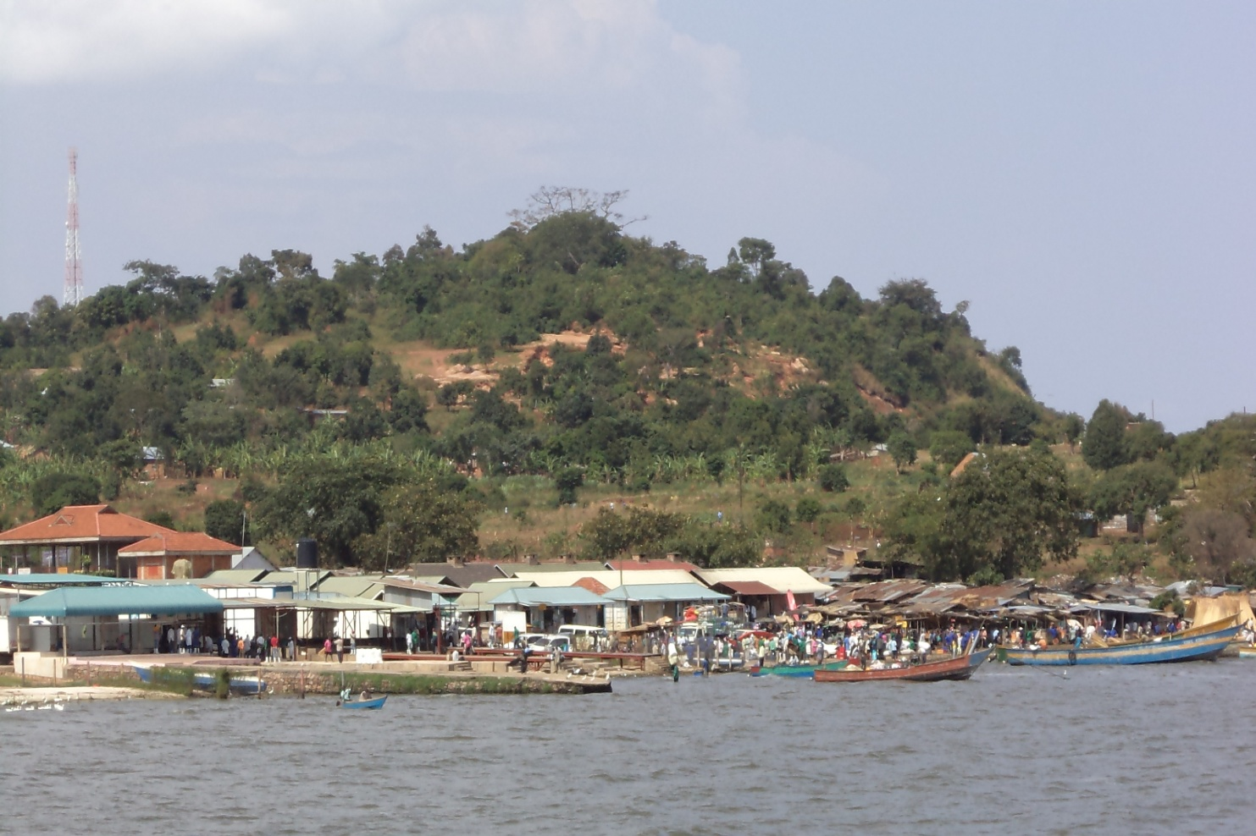2. **Study the photograph provided and answer questions that follow:**

a) Draw a landscape sketch of the area shown on the photograph and on it, mark and name:

(i) Ridge,

(ii) Vegetation types.

(iii) Jetty,

(iv) Telecom mast

(v) Water body *(06 marks)*

b) Identify the economic activity taking place in the right middle ground. *(01 mark)*

(c) (i) Giving evidence from the photograph, describe the factors which have favored the economic activity identified in (b) above. *(04 marks)*

(ii) Outline the problems faced by the people carrying out the activity identified in (b) above. *(03 marks)*

d) Giving reasons for your answer, suggest one area in East Africa where this photograph ought to have been taken. *(02 marks)*

**COMPULSORY QUESTION: FIELDWORK** *(15 marks)*

***Answer all parts of this question***

3.For any one Fieldwork study you have carried out either on a **farm** or an **industry**;

1. State the:
2. Topic of study
3. Objectives of the study *(4 marks)*
4. Draw an annotated relief section of the area studied and on it mark and name:
5. Relief features
6. Man-made features *(5 marks)*
7. Outline the activities you carried out as a follow up to the study. *(3 marks)*
8. Explain the skills gained by the researcher from the field work study. *(3 marks)*

**SECTION B: EAST AFRICA (20 MARKS)**

*Attempt only* ***ONE*** *question from this section.*

4. Study the map of East Africa provided and answer the questions that follow:

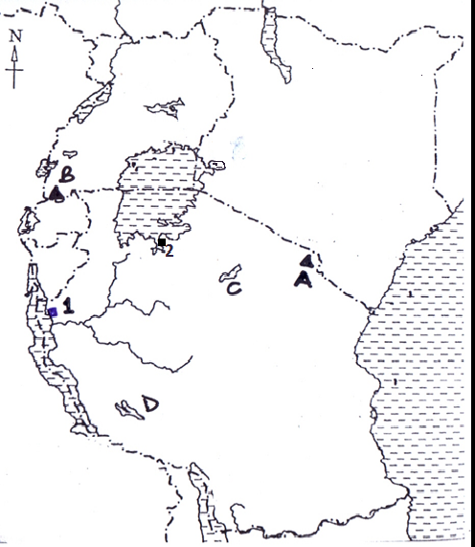

(a) Name the:

(i) Mountains marked A and B

(ii) Lakes marked C and D

(iii) Ports marked 1 and 2 *(06 marks)*

(b) Describe the processes which were responsible for the formation any one lake identified in (a) (ii) above. *(05 marks)*

(c) State the benefit of lakes to the people of East Africa. *(05 marks)*

(d) Outline the problems faced by the people living in the areas near Lakes in East Africa *(04 marks)*

1. Draw a sketch map of East Africa and on it, marks and name;

(a) (i) Industrial centres; Nairobi, Mtwara and Jinja

(ii) Rivers: Tana and Rufigi

(iii) Mountains: Rwenzori and Kilimanjaro. *(08 marks)*

(b) (i) Name any two industries found in any **one** industrial centre marked

in (a) (i) above. *(03 marks)*

(ii) Describe the factors which have favoured the development of industries in the town chosen in (b) (i) above. *(05 marks)*

1. Explain the benefits of industries to the development of East Africa.

*(04marks)*

1. Study table 1: below showing Uganda’s exports in ‘000’ tones in 2010.

|  |  |
| --- | --- |
| **EXPORTS** | **QUANTITY (‘000’ TONNES)** |
| Coffee | 270 |
| Tea | 54 |
| Sand | 25 |
| Maize | 120 |
| Copper | 40 |

1. Draw a bar graph to show the information in the table. *(07 marks)*
2. Calculate the;
3. Percentage of agricultural exports,
4. Percentage of mineral exports

for Uganda in 2010.

*(04 marks)*

1. Explain the problems facing the export sector in Uganda. *(05 marks)*
2. Suggest solutions to the problems in (c) above. *(04 marks)*
3. Study the map of Kenya provided below and use it to answer the questions that follow;

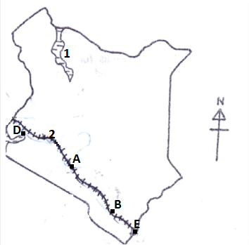

1. Name the:
2. urban centres marked A and B. *(02 marks)*
3. transport route marked C *(01 mark)*
4. water body marked 1 *(01 mark)*
5. ports marked D and E *(02 marks)*

(b) Describe the factors that have led to the development of ports in East Africa. *(04 marks)*

(c) Explain the contributions of ports to the development of East Africa. *(06 marks)*

(d) Outline the problems facing ports in East Africa. *(04 marks)*

**\*\*\*\* END \*\*\*\***